Bahria University,

Karachi Campus



LAB EXPERIMENT NO.

**11**

LIST OF TASKS

|  |  |
| --- | --- |
| TASK NO | OBJECTIVE |
| 01 | Configure RIP on the following network and show all necessary configuration steps for each router. |
| 02 | Configure RIP on the following network and show all necessary configuration steps for each router. |

Submitted On:

**20/12/2023**

**TASK # 1:** Configure RIP on the following network and show all necessary configuration steps for each router.

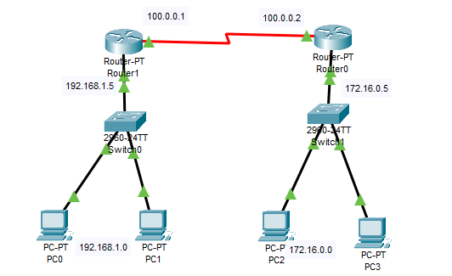

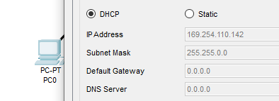 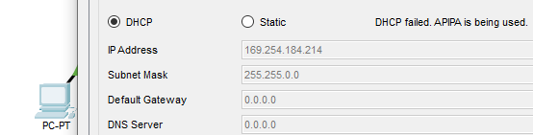

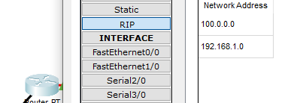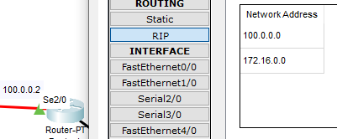

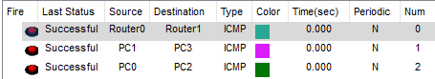

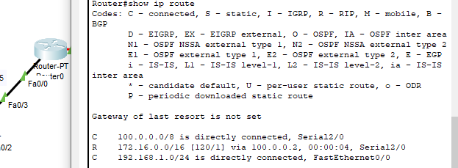

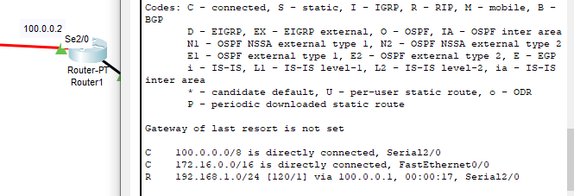

**TASK # 2:** Configure RIP on the following network and show all necessary configuration steps for each router.



